**OnCourse Learning-Your Learning Portal**

**Please view this website via Google Chrome.**

* Employees will still take all their mandatory compliance courses via OnCourse
* Employees will also have access to a number of Professional Development courses

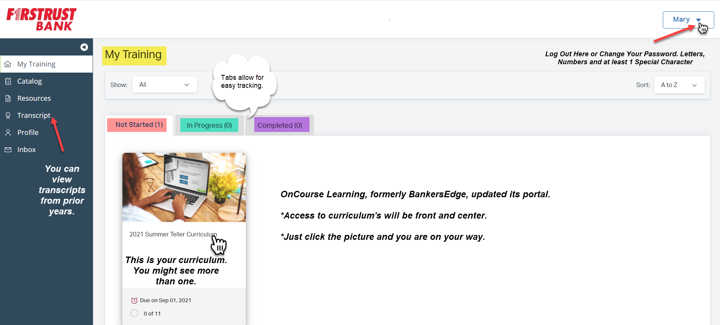

* Employees may also use the new platform as a personal development resource by completing courses on their own.
* Employees can now become locked out. We all have 5 chances. Make sure you make note of your new password after logging in and resetting

**To access OnCourse:**

(1) Click this link <https://portal.betraining.com/login/fsttrstbpa1/>(Please open in Google Chrome)

(2) Login to the site. Your username is your full last name, first initial (for example, rexs).

(3) The first time password for all users will be **Welcome1!.** Then, to change your password (at least 7 characters, with at least one letter, one number, and one special character), click the arrow near the logoff button. **Passwords do not expire!**

Should you experience difficulty accessing the website (a white screen upon log in, contact TSG) or you become locked out of a test due to excessive failures or password lockouts, please click [here](mailto:srex@firstrust.com?subject=Help!%20I%20am%20locked%20out%20of%20OnCourse) to email Susan Rex or call, 610-238-5108.